**Consultation on options to improve safety within prisons: Discussion document 2024**

# **August - September 2024**

# ***Summary and optional submission form***

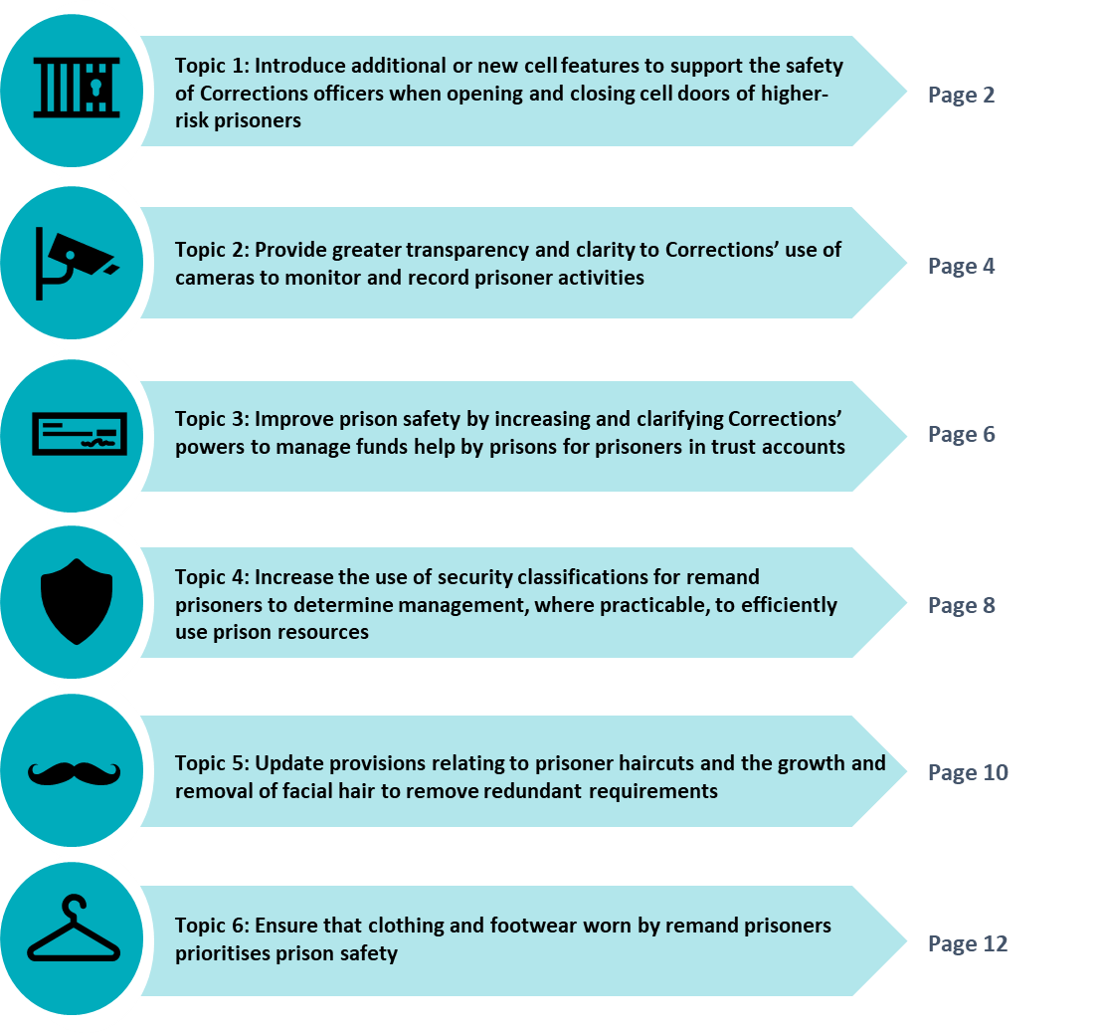

**How to make a submission**

This is an opportunity to share your views, evidence, and data, on how we could improve safety on certain topics in prisons for staff, prisoners, and visitors, to inform final advice to the Minister of Corrections.

You can make a submission by emailing us your views in the body of an email or in an attached Word document or by using this optional submission form [LegislationAmendments@corrections.govt.nz](mailto:LegislationAmendments@corrections.govt.nz). If you wish to discuss your views with us, please email us to let us know. If using this submission form you will find questions in each section to respond to.

**You do not need to respond to all of the questions if you do not wish to**. The submission period closes on 30 September 2024.

## **Your submission is public information**

After public consultation, the contents of submissions (including names of submitters) may be published on the Corrections website and released to the public if requested under the Official Information Act 1982. Unless you clearly specify otherwise in your submission, Corrections will consider that you have consented to website posting of both your submission and your name.

If you think there are grounds to withhold specific information in your submission from publication, please tick the relevant boxes on the next page and describe which parts you consider should be withheld, together with the reasons for withholding the information. Reasons that information can be withheld are set out in sections 6 and 9 of the Official Information Act and may include that the submission discloses personal information. We will take into account any requests to withhold information in submissions when responding to requests under the Official Information Act.

**Submitter information**

Please fill out the **submitter information** below. If you are representing an organisation, please ensure you have the authority to represent its views.

|  |
| --- |
| **Name:** |

|  |  |  |
| --- | --- | --- |
| **Email address:** |  | **Phone number (optional):** |

|  |
| --- |
| **If you are making this submission on behalf of a business or organisation please tell us the title of the company/organisation:** |

Would you like to be kept informed of the outcome of Corrections’ public consultation? Yes/No

**Release of information**: Please indicate if you do not wish your name and contact details to be included in any information that the Department of Corrections may publish. Yes/No

Please indicate if there is other information within your submission that you want to be kept confidential. If you have ticked this box, please state your reasons and grounds under the Official Information Act 1982 below, for consideration by the Department of Corrections. Yes/No

|  |
| --- |
|  |

# **Topic 1: Introduce additional or new cell features to support the safety of Corrections officers when opening and closing cell doors of higher-risk prisoners**

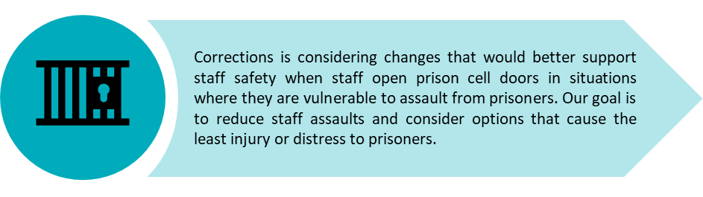

**What’s the problem we are trying to address?**

Despite existing safety measures such as windows in cell doors that enable staff to see where a prisoner is in a cell before the door is opened, staff are still vulnerable to assault from prisoners when opening a prison cell door. Data from across the prison network shows that in units managing more volatile and higher-security prisoners some prisoners appear compliant until the door is opened and then suddenly rush the staff member thereby assaulting them. Assaults on staff can have wider impacts on Corrections. If staff need to take time off following the assault this impacts the individual who is taking time off and also the wider prison.

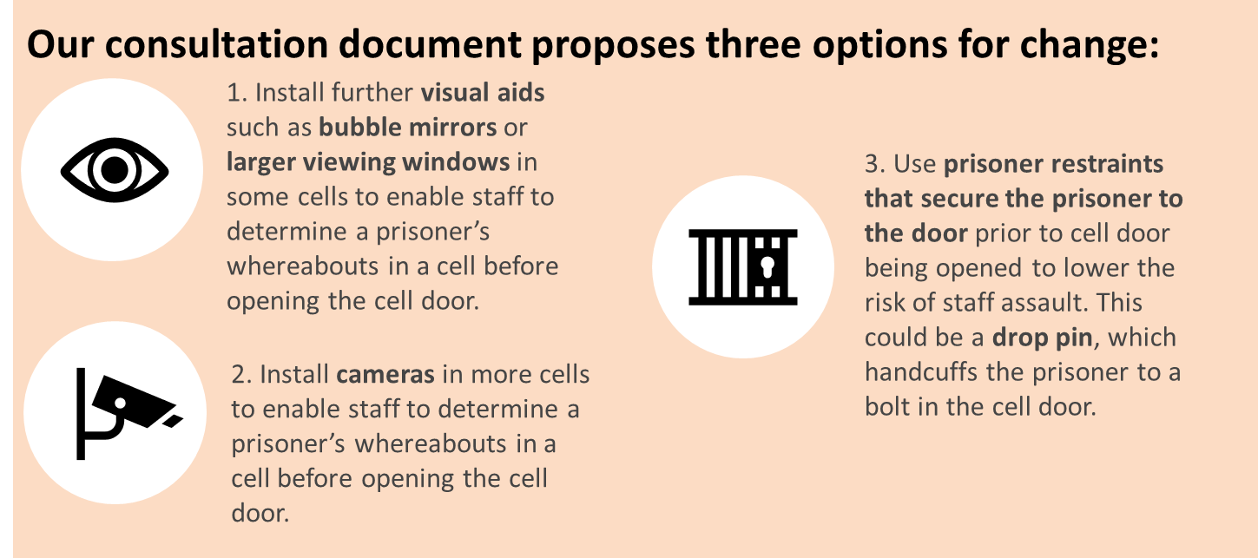**See pages 10 to 13 of the consultation document for more detail and our analysis of the options.**

**Questions we seek your feedback on for topic 1: new cell features to support staff safety**

**You may wish to consider the following criteria as you give us your feedback on the options:**

|  |  |
| --- | --- |
| * Contributes to the good order and safety of prisoners and the prison | * Practical to implement and responsive |
| * Transparency and accountability | * Complies with human rights standards |
| * Promotes better outcomes for prisoners | * Addresses Māori needs and cultural perspectives. |

*More information about how to use these criteria is on page 4 of the consultation document.*

**Question 1: Do you think that Corrections staff require additional tools to support their safety when opening and closing cell doors in units managing higher-risk prisoners?**

|  |
| --- |
|  |

**Question 2: Which option do you think would be the most effective and are there any other options to support staff safety when opening cell doors that we should consider?**

|  |
| --- |
|  |

**Question 3:** **In addition to maximum security and management units, are there any other cells where these features should be considered?**

|  |
| --- |
|  |

**Question 4:** **Are there any advantages and/or disadvantages for the proposed options that you think we have missed?** *See pages 12 and 13 of the consultation document for more information.*

|  |
| --- |
|  |

**Question 5:** **Are there any other Māori or other cultural perspectives that should be considered?** *See page 13 of the consultation document for more information.*

|  |
| --- |
|  |

# **Topic 2: Provide greater transparency and clarity to Corrections’ use of cameras to monitor and record prisoner activities**

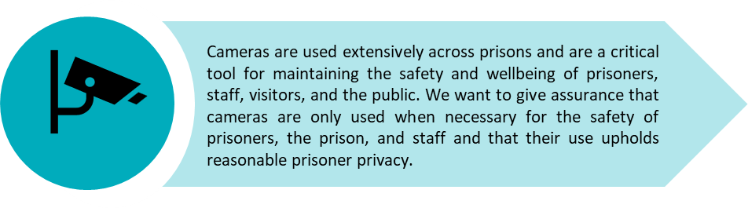

**What’s the problem we are trying to address?**

Corrections currently has internal rules that guide how cameras operate. We are proposing changes to provide greater clarity around where and when cameras can be used to monitor and record prisoners. This includes safeguards for situations where cameras are likely to capture intimate recordings of prisoners, such as using the toilet or discussing private information with health practitioners.

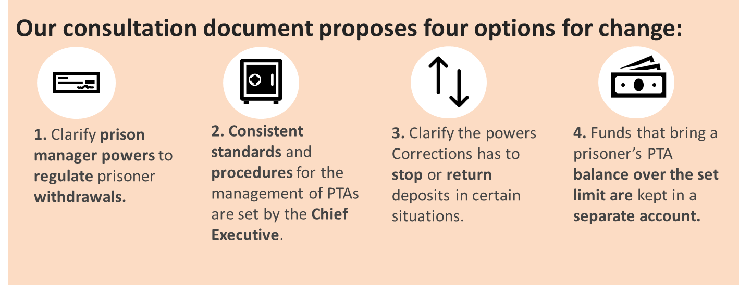**See pages 16 to 18 of the consultation document for more detail and our analysis of the options.**

**Questions we seek your feedback on for topic 2: transparency and clarity of camera use**

**You may wish to consider the following criteria as you give us your feedback on the options:**

|  |  |
| --- | --- |
| * Contributes to the good order and safety of prisoners and the prison | * Practical to implement and responsive |
| * Transparency and accountability | * Complies with human rights standards |
| * Promotes better outcomes for prisoners | * Addresses Māori needs and cultural perspectives. |

*More information about how to use these criteria is on page 4 of the consultation document.*

**Question 6: Do you think that there are more benefits to specifying where cameras can be placed, or by specifying where they cannot be placed? Why do you think that?**

|  |
| --- |
|  |

**Question 7: Do you agree that cameras should not be used to monitor or record inside the above listed areas? Please explain why.**

|  |
| --- |
|  |

**Question 8: Are there any advantages and/or disadvantages of the proposed options that you think we have missed?** *See pages 17 and 18 of the consultation document for more information.*

|  |
| --- |
|  |

**Question 9: Are there any other Māori or other cultural perspectives that should be considered?** *See page 18 of the consultation document for more information.*

|  |
| --- |
|  |

# **Topic 3: Improve prison safety by increasing and clarifying Corrections’ power to manage funds held in prisoner trust accounts**

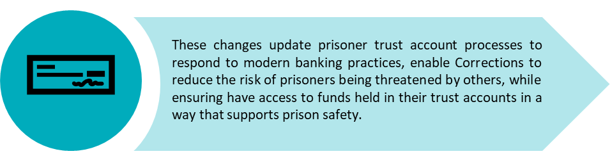

**What’s the problem we are trying to address?**

Under the Act, when a prisoner enters prison, one or more trust accounts that exclusively hold money for particular prisoners must be opened and operated. However, the regulatory framework for prisoner trust account is outdated and does not reflect modern banking practices, and Corrections has limited powers to manage prisoner trust accounts in a way that reduces transactions that may not support the good order and safety of prisons and prisoners.

**See pages 21 to 24 of the consultation document for more detail and our analysis of the options.**

**Questions we seek your feedback on for topic 3: managing funds held in prisoner trust accounts**

**You may wish to consider the following criteria as you give us your feedback on the options:**

|  |  |
| --- | --- |
| * Contributes to the good order and safety of prisoners and the prison | * Practical to implement and responsive |
| * Transparency and accountability | * Complies with human rights standards |
| * Promotes better outcomes for prisoners | * Addresses Māori needs and cultural perspectives. |

*More information about how to use these criteria is on page 4 of the consultation document.*

**Question 10: What are your preferred options to ensure prisoner trust accounts support prisoner needs and limit negative impacts on the good order and safety of prisons? Please explain why.**

|  |
| --- |
|  |

**Question 11: Are there any other options to address these issues that we should consider?**

|  |
| --- |
|  |

**Question 12: Do you think that prisoners should have their withdrawals or deposits declined if staff recognise that the transaction could be coming or going to other prisoners and may indicate intimidation or other activity that does not support the good order and safety of prisons? Are there any other reasons why withdrawals or deposits should be declined?**

|  |
| --- |
|  |

**Question 13: Can you think of any other standards or processes that should be consistent across the prisoner trust account network?** *See page 22 of the consultation document for more information.*

|  |
| --- |
|  |

**Question 14: Are there any other reasons prisoners should be able to access large deposits, or deposits that take their prisoner trust account balance over the limit?** *See page 23 of the consultation document for more information.*

|  |
| --- |
|  |

**Question 15: Have we identified all the advantages and disadvantages of increasing and clarifying our powers to manage prisoner trust account transactions and accounts accurately? Are we missing anything?** *See pages 23 and 24 of the consultation document for more information.*

|  |
| --- |
|  |

**Question 16:** **Are there any other Māori or other cultural perspectives that should be considered? Are there any other impacts that we should consider?** *See page 24 of the consultation document for more information.*

|  |
| --- |
|  |

# **Topic 4: Increasing the use of security classifications for remand prisoners to determine their management, where practicable**

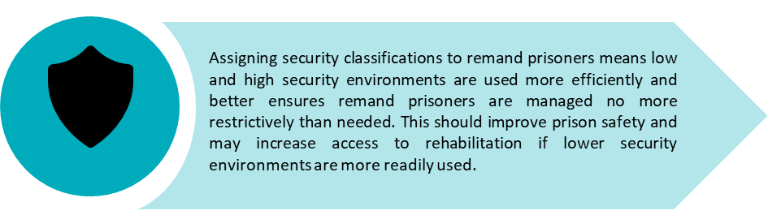

**What’s the problem we are trying to address?**

Remand prisoners are currently managed within high security environments as the default position. However, in some cases, remand prisoners could be safely managed in lower security environments. Managing prisoners in high security environments can have negative impacts, such as fewer unlock hours for prisoners and less access to programmes, as well as impacting Corrections’ ability to use prisoner accommodation flexibly over the long term.

We are proposing that Corrections assess all remand prisoners and assign a security classification within a certain timeframe after entering prison. This will better support Corrections to manage remand prisoners in a way that aligns with their security risk. It will also assist Corrections to ensure that remand prisoners are managed with no more restrictions than needed, taking into account available prison accommodation, and Corrections’ resources.

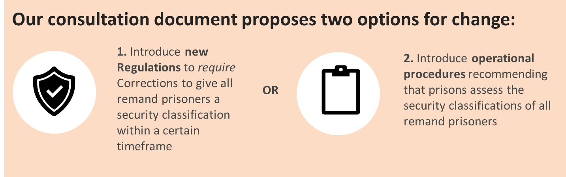**See pages 27 to 30 of the consultation document for more detail and our analysis of the options.**

**Questions we seek your feedback on for topic 4:** **security classifications for remand prisoners**

**You may wish to consider the following criteria as you give us your feedback on the options:**

|  |  |
| --- | --- |
| * Contributes to the good order and safety of prisoners and the prison | * Practical to implement and responsive |
| * Transparency and accountability | * Complies with human rights standards |
| * Promotes better outcomes for prisoners | * Addresses Māori needs and cultural perspectives. |

*More information about how to use these criteria is on page 4 of the consultation document.*

**Question 17: Do you think that a mandatory requirement to give remand prisoners a security classification (option one) or the use of non-regulatory measures (option two) is the best way to continue to increase Corrections’ use of a tool, such as the RMT?**

|  |
| --- |
|  |

**Question 18: Do you think there are any additional advantages or disadvantages relating to remand prisoners having their security risk assessed upon entry to prison that we have not considered?** *See pages 28 to 30 of the consultation document for more information.*

|  |
| --- |
|  |

**Question 19: Are there other reasons it is important to use a classification system for remand prisoners?** *See pages 26 and 27 of the consultation document for more information.*

|  |
| --- |
|  |

**Question 20:** **Within what timeframe should any classification be undertaken? What would be your reason for choosing that timeframe?**

|  |
| --- |
|  |

**Question 21: Are there any other Māori or other cultural perspectives that should be considered?** *See page 29 of the consultation document for more information.*

|  |
| --- |
|  |

**Question 22: Do you have any further comments to make?**

|  |
| --- |
|  |

# **Topic 5: Updating provisions relating to prisoner haircuts and the growing and removal of facial hair to remove redundant requirements**

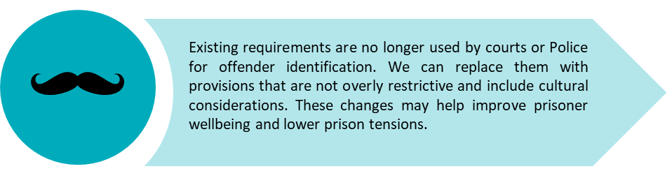

**What’s the problem we are trying to address?**

Sentenced and convicted prisoners can generally have the hairstyle of their choice, unless the health centre manager directs that they must not have that hairstyle or facial hair on the grounds of health, safety, or cleanliness. However, convicted or sentenced prisoners must not grow a beard or moustache after arriving in prison, if they did not already have one, unless this is first approved by the prison manager.

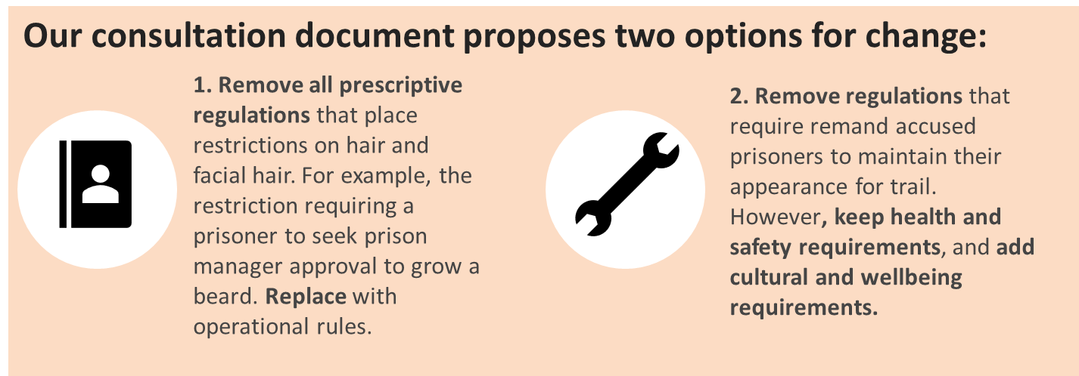**See pages 32 to 24 of the consultation document for more detail and our analysis of the options.**

**Questions we seek your feedback on for topic 5: prisoner haircuts facial hair**

**You may wish to consider the following criteria as you give us your feedback on the options:**

|  |  |
| --- | --- |
| * Contributes to the good order and safety of prisoners and the prison | * Practical to implement and responsive |
| * Transparency and accountability | * Complies with human rights standards |
| * Promotes better outcomes for prisoners | * Addresses Māori needs and cultural perspectives. |

*More information about how to use these criteria is on page 4 of the consultation document.*

**Question 23: Do you think that the current provisions in relation to haircuts and facial hair need to be updated? Please explain why you agree or disagree.**

|  |
| --- |
|  |

**Question 24: Are there any other options to address these issues relating to haircuts and facial grooming that we should consider?**

|  |
| --- |
|  |

**Question 25: Are there any other prisoner rights, in addition to wellbeing and cultural sensitivity, that should be considered or addressed in the haircut and facial hair regulations? Should we consider any other cultural perspectives?**

|  |
| --- |
|  |

**Question 26: Are there any advantages and/or disadvantages of the proposed options that you think we have missed?** *See pages 33 and 34 of the consultation document for more information.*

|  |
| --- |
|  |

# **Topic 6: Ensuring that the clothing of remand accused prisoners prioritises prison safety**

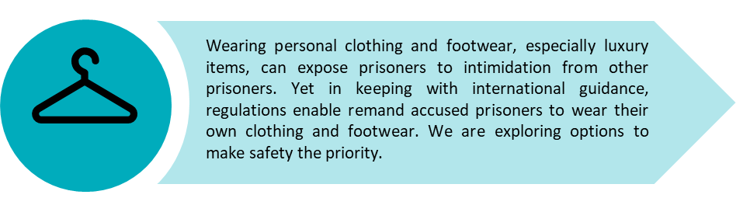

**What’s the problem we are trying to address?**

In keeping with international guidance, as remand prisoners are not convicted, prison managers are provided with more flexibility as to whether remand accused prisoners can wear their own clothing and footwear, as opposed to prison issued clothing and footwear. However, wearing personal clothing and footwear, especially luxury items, can expose remand accused prisoners to intimidation from other prisoners.

**See pages 36 to 28 of the consultation document for more detail and our analysis of the options.**

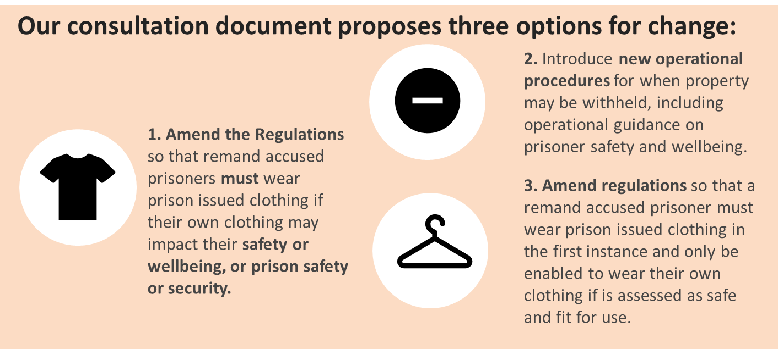

**Questions we seek your feedback on for topic 5:** **clothing of remand accused prisoners**

**You may wish to consider the following criteria as you give us your feedback on the options:**

|  |  |
| --- | --- |
| * Contributes to the good order and safety of prisoners and the prison | * Practical to implement and responsive |
| * Transparency and accountability | * Complies with human rights standards |
| * Promotes better outcomes for prisoners | * Addresses Māori needs and cultural perspectives. |

*More information about how to use these criteria is on page 4 of the Discussion Document.*

**Question 27: Do you agree that we should more clearly require that prisoner safety is a priority when it comes to enabling remand accused prisoners to wear their own clothes and footwear? Why or why not?**

|  |
| --- |
|  |

**Question 28: Are there any other options to address these issues that we should consider?**

|  |
| --- |
|  |

**Question 29: Are there any advantages and/or disadvantages of the proposed options that you think we have missed?** *See pages 37 and 38 of the consultation document for more information.*

|  |
| --- |
|  |

**Question 30: Should similar provisions apply to sentenced prisoners, particularly in relation to footwear, given that it is common for convicted and sentenced prisoners to wear their own footwear?**

|  |
| --- |
|  |

# **Implementation and monitoring of proposals**

**Question 31:** Any regulatory changes would be supplemented by updated training for Corrections staff. Additionally, guidance on the updated processes and procedures would need to be given to both Corrections staff and prisoners, as well as to family and friends in the community. Clear communication will be needed before any changes come into effect, as this will give time for prisoners and their friends and families, and staff to adjust, and answer any questions they may have.

**What do you think Corrections needs to consider when implementing the proposed options?**

|  |
| --- |
|  |

**Question 32:** Corrections will conduct a review of the policy changes 12-18 months following implementation, to provide information to enable it to evaluate how the new policies are working operationally and to determine whether any of the changes are having unintended consequences.

**What do you think Corrections needs to consider when monitoring and evaluating the implementation of the proposed options?**

|  |
| --- |
|  |